Lab task 7b
Talal Ali 24k0863
Task 1:
#include <iostream>
#include <string> using namespace std;
class DispatchRecord {
public:
int DispatchID;
string CustomerName;
int DeliveryTime;
void input() {
cout << "Enter Dispatch ID: ";
cin >> DispatchID;
cin.ignore();
cout << "Enter Customer Name: ";
getline(cin, CustomerName);
cout << "Enter Delivery Time (in minutes): ";
cin >> DeliveryTime; }
void display() const {
cout << DispatchID << "\t" << CustomerName << "\t" << DeliveryTime <<
endl; }
};
int partition(DispatchRecord arr[], int low, int high) { int pivot = arr[high].DeliveryTime;
int i = low - 1;
for (int j = low; j < high; j++) { if (arr[j].DeliveryTime < pivot) {
i++;
swap(arr[i], arr[j]);
}
}
swap(arr[i + 1], arr[high]);
return i + 1;
}
void quickSort(DispatchRecord arr[], int low, int high) {
if (low < high) {
int pi = partition(arr, low, high);
quickSort(arr, low, pi - 1); quickSort(arr, pi + 1, high);
}
}
int main() {
int n = 5;
DispatchRecord records[] = {
{101, "Ali", 35},
{102, "Sara", 20},
{103, "Ahmed", 50},
{104, "Noor", 15},
{105, "Hasan", 25}
};
cout << "\n--- Records Before Sorting ---\n";
cout << "ID\tName\tDeliveryTime\n"; for (int i = 0; i < n; i++)
records[i].display();
quickSort(records, 0, n - 1);
cout << "\n--- Records After Sorting (by Delivery Time) ---\n";
cout << "ID\tName\tDeliveryTime\n";
for (int i = 0; i < n; i++)
records[i].display();
return 0;
}

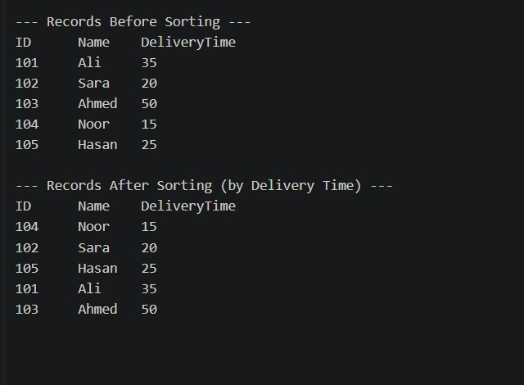
Task 2:
#include <iostream>
using namespace std;
int getMax(int arr[], int n) { int maxVal = arr[0];
for (int i = 1; i < n; i++) {
if (arr[i] > maxVal)
maxVal = arr[i]; }
return maxVal;
}
void countingSort(int arr[], int n, int exp) {
int output[100];
int count[10] = {0};
for (int i = 0; i < n; i++)

count[(arr[i] / exp) % 10]++;
for (int i = 1; i < 10; i++) count[i] += count[i - 1];
for (int i = n - 1; i >= 0; i--) {
int digit = (arr[i] / exp) % 10; output[count[digit] - 1] = arr[i];
count[digit]--;
}
for (int i = 0; i < n; i++)
arr[i] = output[i];
}
void radixSort(int arr[], int n) {
int maxVal = getMax(arr, n);
for (int exp = 1; maxVal / exp > 0; exp *= 10) { cout << "\nSorting by digit place: " << exp << endl;
countingSort(arr, n, exp);
cout << "Intermediate result: "; for (int i = 0; i < n; i++)
cout << arr[i] << " ";
cout << endl;
}
}
int main() {
int n;
cout << "Enter number of account numbers: "; cin >> n;
int accounts[100];
cout << "\nEnter " << n << " account numbers (7-digit):\n"; for (int i = 0; i < n; i++)
cin >> accounts[i];
cout << "\n--- Account Numbers Before Sorting ---\n"; for (int i = 0; i < n; i++)
cout << accounts[i] << " ";
cout << endl;
radixSort(accounts, n);
cout << "\n--- Account Numbers After Sorting ---\n";
for (int i = 0; i < n; i++) cout << accounts[i] << " ";
cout << endl;
return 0; }

